Computer Organization &Architecture

UNIT-I
Syllabus:
Revision of basics in Boolean logic and Combinational/Sequential Circuits Functional blocks of a computer: CPU, memory, input-output subsystems, control unit.
Instruction set architecture of a CPU: Registers, instruction execution cycle, RTL interpretation of instructions, addressing modes, instruction set. Outlining instruction sets of some common CPUs.
Data representation: Signed number representation, fixed and floating point representations, character representation.

What is computer organization?
Ans: Computer Organization is concerned with the structure and behaviour of a computer system as seen by the user. It deals with the components of a connection in a system. Computer Organization tells us how exactly all the units in the system are arranged and interconnected. Whereas Organization expresses the realization of architecture. An organization is done on the basis of architecture. Computer Organization deals with low-level design issues. Organization involves Physical Components (Circuit design, Adders, Signals, and Peripherals).
Why we study the computer organization?
Computer Architecture | Computer Organization
Computer Architecture is concerned with the way hardware components are connected together to form a computer system. | Computer Organization is concerned with the structure and behaviour of a computer system as seen by the user.
It acts as the interface between hardware and software. | It deals with the components of a connection in a system.
Computer Architecture helps us to understand the functionalities of a system. | Computer Organization tells us how exactly all the units in the system are arranged and interconnected.
A programmer can view architecture in terms of instructions, addressing modes and registers. | Whereas Organization expresses the realization of architecture.
While designing a computer system architecture is considered first. | An organization is done on the basis of architecture.
Computer Architecture deals with high-level design issues. | Computer Organization deals with low-level design issues.
Architecture involves Logic (Instruction sets, Addressing modes, Data types, Cache optimization) | Organization involves Physical Components (Circuit design, Adders, Signals, Peripherals)
Ans: Computer Organization and Architecture lets you know how exactly each instruction is executed at the micro level.

Difference between the Combinational Circuits and Sequential Circuits:
Parameters | Combinational Circuit | Sequential Circuit
Meaning and Definition | It is a type of digital circuit that generates an output by relying on the input it receives at that instant, and it stays independent of time.  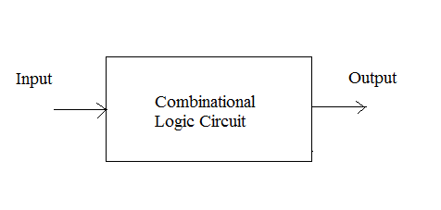 | It is a type of digital circuit in which the output relies on the current input and the previous output.  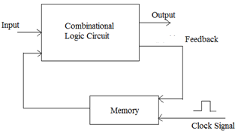
Feedback | A Combinational Circuit requires no feedback for generating the next output. It is because its output has no dependency on the time instance. | The output of a Sequential Circuit, on the other hand, relies on both- the previous output and the current input. So, the output generated from the previous output gets transferred in the form of feedback. The circuit uses it (along with inputs) for generating the next output.
Performance | Only the current state of input is required for a Combinational Circuit. Thus, it performs much faster and better in comparison with the Sequential Circuit. | In the case of a Sequential Circuit, the performance is very slow. Its dependency on the previous outputs makes the process much more complex.
Complexity | It is very less complex in comparison. It is basically lacks implementation of feedback. | It is always more complex in its nature and functionality, because it implements the feedback, depends on previous outputs and also on clocks.
Elementary Blocks | Logic gates are the building/ elementary blocks of a Combinational Circuit. | Flip-flops are the building/ elementary blocks of a Sequential Circuit.
Operation | These types of circuits can be used for both- Boolean as well as Arithmetic operations. | These types of circuits can be used for storing data.
Examples | Multiplexer, Encoder, Decoder, Half-adder, Full-adder etc. | Registers, Counters, etc.
What is a Computer/Digital Computer?
It is a fast electronic computing device that
- accepts the input
- processes the accepted input(according to the internally stored instructions) and
- produces the output
Type of Computers:
Computers are classified into many categories based on size, cost and performance.
1. Embedded computers:
These are integrated into a larger device in order to automatically monitor and control a physical process or environment. Ex: AC, Washing Machine, Microwave Oven etc.
2. Personal computers:
These are the most common type computer in homes, schools, offices etc. It is the most common type of desk top computers with processing and storage units along with various input and output devices.
3. Portable/Notebook computers:
This type of computers provides the basic features of a personal computer in a smaller lightweight package. They can operate on batteries to provide mobility.
4. Workstation computers:
These are used in engineering applications of interactive design work, where the applications require a high computational capacity.
5. Enterprise computers:
These are used for business data processing in medium to large organizations that require much more computing power and storage capacity than work stations and also these computers are meant for sharing the data among more numbers of users via some form communication network.
6. Mainframe computers:
These are Large and expensive computers capable of simultaneously processing data for hundreds or thousands of users. Used to store, manage, and process large amounts of data that need to be reliable, secure, and centralized.
7. Super computers:
A computer considered to be the fastest in the world. It is used to execute tasks that would take lot of time for other computers. Ex: Weather forecasting systems.

Revision of basics in Boolean logic:
Boolean logic: Computer circuitry works based on Boolean logic (Boolean algebra): operation on True (1) and False (0) values. Boolean algebra was invented by George Boole in 1854.
Boolean algebra can be considered as an algebra that deals with binary variables and logic operations. Boolean algebra variables are designated by letters such as A, B, X, The basic operations performed are AND, OR, and Complement.

Rule in Boolean algebra:
Following are the important rules used in Boolean algebra.
- Variable used can have only two values. Binary 1 for HIGH and Binary 0 for LOW.
- Complement of a variable is represented by an overbar (-). Thus, complement of variable B is represented as . Thus if B = 0 then = 1 and B = 1 then = 0.
- ORing of the variables is represented by a plus (+) sign between them. For example ORing of A, B, C is represented as A + B + C.
- Logical ANDing of the two or more variable is represented by writing a dot between them such as A.B.C. Sometime the dot may be omitted like ABC.

Laws of Boolean Algebra:
There are six types of Boolean algebra laws. They are:
- Commutative law
- Associative law
- Distributive law
- AND law
- OR law
- Inversion law
Commutative Law
Any binary operation which satisfies the following expression is referred to as a commutative operation. Commutative law states that changing the sequence of the variables does not have any effect on the output of a logic circuit.
- A. B = B. A
- A + B = B + A

Associative Law
It states that the order in which the logic operations are performed is irrelevant as their effect is the same.
- (A. B). C = A. (B. C )
- ( A + B ) + C = A + ( B + C)

Distributive Law
Distributive law states the following conditions:
- A. ( B + C) = (A. B) + (A. C)
- A + (B. C) = (A + B). ( A + C)
AND Law
These laws use the AND operation. Therefore they are called AND laws.
- A .0 = 0
- A . 1 = A
- A. A = A
- A.A¯=0

OR Law
These laws use the OR operation. Therefore they are called OR laws.
- A + 0 = A
- A + 1 = 1
- A + A = A
- A+A¯=1

Inversion Law
In Boolean algebra, the inversion law states that double inversion of variable results in the original variable itself.
- A¯¯=A

Boolean Algebra Theorems
The two important theorems which are extremely used in Boolean algebra are De Morgan’s First law and De Morgan’s second law. These two theorems are used to change the Boolean expression. This theorem basically helps to reduce the given Boolean expression in the simplified form. These two De Morgan’s laws are used to change the expression from one form to another form. Now, let us discuss these two theorems in detail.
De Morgan’s First Law:
De Morgan’s First Law states that (A.B)’ = A’+B’.
The first law states that the complement of the product of the variables is equal to the sum of their individual complements of a variable.
The truth table that shows the verification of De Morgan’s First law is given as follows:
A | B | A’ | B’ | (A.B)’ | A’+B’
0 | 0 | 1 | 1 | 1 | 1
0 | 1 | 1 | 0 | 1 | 1
1 | 0 | 0 | 1 | 1 | 1
1 | 1 | 0 | 0 | 0 | 0
The last two columns show that (A.B)’ = A’+B’.
Hence, De Morgan’s First Law is proved.
De Morgan’s Second Law:
De Morgan’s Second law states that (A+B)’ = A’. B’.
The second law states that the complement of the sum of variables is equal to the product of their individual complements of a variable.
The following truth table shows the proof for De Morgan’s second law.
A | B | A’ | B’ | (A+B)’ | A’. B’
0 | 0 | 1 | 1 | 1 | 1
0 | 1 | 1 | 0 | 0 | 0
1 | 0 | 0 | 1 | 0 | 0
1 | 1 | 0 | 0 | 0 | 0
The last two columns show that (A+B)’ = A’. B’.
Hence, De Morgan’s second law is proved.
The other theorems in Boolean algebra are complementary theorem, duality theorem, transposition theorem, redundancy theorem and so on. All these theorems are used to simplify the given Boolean expression. The reduced Boolean expression should be equivalent to the given Boolean expression.
Functional blocks of a computer

A computer consists of five main functional parts: input, memory, arithmetic and logic, output, and control units, as shown in Figure (1).
- The input unit accepts coded information from human operators using devices such as keyboards, or from other computers over digital communication lines.
- The information received is stored in the computer’s memory, either for later use or to be processed immediately by the arithmetic and logic unit. The processing steps are specified by a program that is also stored in the memory.
- Finally, the results are sent back to the outside world through the output unit.
- All of these actions are coordinated by the control unit. An interconnection network provides the path for the functional units to exchange information and coordinate their actions.
The information handled by a computer. In general, the information in the computer categorized as either instructions or data.
- Instructions, or machine instructions, are explicit commands that govern the transfer of information within a computer as well as between the computer and its I/O devices
- Specify the arithmetic and logic operations to be performed.
- Data are numbers and characters that are used as operands by the instructions. Data are also stored in the memory.
- A program is a list of instructions which performs a task. Programs are stored in the memory. The processor fetches the program instructions from the memory, one after another, and performs the desired operations. The computer is controlled by the stored program, except for possible external interruption by an operator or by I/O devices connected to it.
The instructions and data handled by a computer must be encoded in a system understandable format. Each instruction, number, or character is encoded as a string of binary digits called bits, each having
one of two possible values, 0 or 1.
Figure (1): Basic functional unis of a computer

- Input Unit
Computers accept information through input units. The most common input device is the keyboard. Whenever a key is pressed, the corresponding letter or digit is automatically translated into its corresponding binary code and transmitted to the processor.
- Many other kinds of input devices for human-computer interaction are available, including the touchpad, scanner, bar code reader, mouse, joystick, and trackball etc.
- Microphones can be used to capture audio input which is then sampled and converted into digital codes for storage and processing.
- Cameras (like a web cam) can be used to capture video input.
- Digital communication facilities, such as the Internet, can also provide input to a computer from other computers and database servers.

- Output Unit
The output unit is the opposite functional unit to the input unit. Its function is to send processed results to the outside world. A familiar example of such a device is a monitors to display the result/output from the computer.
- Some other output devices are printers and plotters (to get the output from computer in the form of printout).
- Headphones and Speakers (to get the output in the form of audio),
Some units provide both an output and input functions like the touchscreen, modem etc. Such kind of units are called as an input/output (I/O) unit.
- Memory Unit
The function of the memory unit is to store programs and data. There are two types of memory,
- Primary memory
- Secondary memory.

Primary Memory
Primary memory, also called main memory, is a fast memory that operates at electronic speeds. Programs must be stored in this memory while they are being executed.
- The memory consists of a large number of semiconductor storage cells, each capable of storing one bit of information. Cells are handled in groups of fixed size called words. The memory is organized so that one word can be stored or retrieved in one basic operation.
- To provide easy access to any word in the memory, a distinct address is associated with each memory location. A particular word is accessed by specifying its address. Instructions and data can be written into or read from the memory under the control of the processor.
- A memory in which any location can be accessed in a short and fixed amount of time after specifying its address is called a random-access memory (RAM). The time required to access one word is called the memory access time. It typically ranges from a few nanoseconds (ns) to about 100 ns for current RAM units.
Cache Memory
In addition to the main memory, there is a smaller and faster memory is called a cache. It is used to hold sections of a program that are currently being executed, along with any associated data. The cache is tightly coupled with the processor and is usually contained on the same IC chip. The purpose of the cache is to facilitate high instruction execution rates.
- When the execution of an instruction requires data located in the main memory, the data are fetched and copies are also placed in the cache.
- Now, suppose a number of instructions are executed repeatedly as happens in a program loop. If these instructions are available in the cache, they can be fetched quickly during the period of repeated use.

Secondary Storage
Although primary memory is essential, it tends to be expensive and does not retain information when power is turned off. Thus additional to that, less expensive permanent secondary storage is used when large amounts of data and many programs have to be stored, particularly for information that is accessed infrequently. Access times for secondary storage are longer than for primary memory. A wide range of secondary storage devices are available including magnetic disks, optical disks (DVD and CD), Hard disks, USB and flash memory devices.
- Arithmetic and Logic Unit
Most computer operations are executed in the arithmetic and logic unit (ALU) of the processor. Any arithmetic or logic operation such as addition, subtraction, multiplication, division, or comparison of numbers, is initiated by bringing the required operands into the processor, where the operation is performed by the ALU.
- For example, if two numbers located in the memory are to be added, they are brought into the processor, and the addition is carried out by the ALU. The sum may then be stored in the memory or retained in the processor for immediate use if it requires.
- When operands are brought into the processor, they are stored in high-speed storage elements called registers. Each register can store one word of data. Access times to registers are even shorter than access times to the cache unit on the processor chip.
- Control Unit
The memory, arithmetic and logic and I/O units store and process information and perform input and output operations. The operation of these units must be coordinated in some way. This is the responsibility of the control unit. The control unit effectively sends control signals to other units and senses their states. Control circuits are responsible for generating the timing signals that govern the transfers and determine when a given action is to take place.
A control unit is a well-defined, physically separate unit that interacts with other parts of the computer. Much of the control circuitry is physically distributed throughout the computer. A large set of control lines (wires) carries the signals used for timing and synchronization of events in all units. The operation of a computer can be summarized as follows:
- The computer accepts information in the form of programs (instructions) and data through an input unit and stores it in the memory
- Information stored in the memory is fetched under program control into an arithmetic and logic unit, where it is processed.
- Processed information leaves the computer through an output unit.
- All activities in the computer are directed by the control unit.

Input/output Subsystem

The I/O subsystem of a computer provides an efficient mode of communication between the central system and the outside environment. It handles all the input-output operations of the computer system.
Peripheral Devices:
Input or output devices that are connected to computer are called peripheral devices. These devices are designed to read information into or out of the memory unit upon command from the CPU and are considered to be the part of computer system. These devices are also called peripherals.For example: Keyboards, display units and printers are common peripheral devices. There are three types of peripherals:
- Input peripherals: Allows user input, from the outside world to the computer. Example: Keyboard, Mouse etc.
- Output peripherals: Allows information output, from the computer to the outside world. Example: Printer, Monitor etc.
- Input-Output peripherals: Allows both input (from outside world to computer) as well as, output (from computer to the outside world). Example: Touch screen etc.
Interfaces:
Interface is a shared boundary between two separate components of the computer system which can be used to attach two or more components to the system for communication purposes.There are two types of interface:
- CPU Inteface
- I/O Interface
Input-Output Interface:
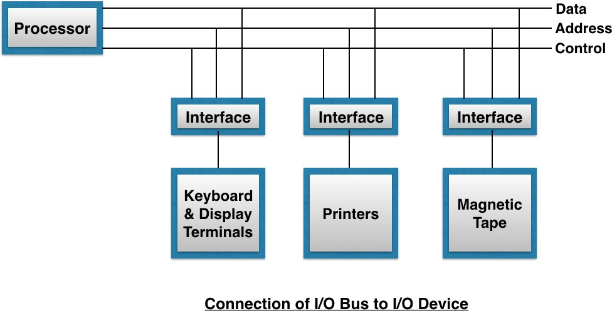
Peripherals connected to a computer need special communication links for interfacing with CPU. In computer system, there are special hardware components between the CPU and peripherals to control or manage the input-output transfers. These components are called input-output interface units because they provide communication links between processor bus and peripherals. They provide a method for transferring information between internal system and input-output devices.

The Input/output Interface is required because there are exists many differences between the central computer and each peripheral while transferring information. Some major differences are:
Peripherals are electromechanical and electromagnetic devices and their manner of operation is different from the operation of CPU, Memory, which are electronic device. Therefore, a conversion of signal values may be required.
  - The data transfer rate of peripherals is usually slower than the transfer rate of CPU, and consequently a synchronisation mechanism is needed.
  - Data codes and formats in peripherals differ from the word format in the CPU and Memory.
  - The operating modes of peripherals are differ from each other and each must be controlled so as not to disturb the operation of other peripherals connected to CPU.

These differences are resolved through input-output interface. As input-output interface (Interface Unit) contain various components, each of which performs one or more vital function for smooth transforming of information between CPU and Peripherals.

Input/Output Channels:
A channel is an independent hardware component that co-ordinate all I/O to a set of controllers. Computer systems that use I/O channel have special hardware components that handle all I/O operations.
Channels use separate, independent and low cost processors for its functioning which are called Channel Processors.
Channel processors are simple, but contains sufficient memory to handle all I/O tasks. When I/O transfer is complete or an error is detected, the channel controller communicates with the CPU using an interrupt, and informs CPU about the error or the task completion.
Each channel supports one or more controllers or devices. Channel Programs contain list of commands to the channel itself and for various connected controllers or devices. Once the operating system has prepared a list of I/O commands, it executes a single I/O machine instruction to initiate the channel program, the channel then assumes control of the I/O operations until they are completed.
IBM 370 I/O Channel
The I/O processor in the IBM 370 computer is called a Channel. A computer system configuration includes a number of channels which are connected to one or more I/O devices.

Categories of I/O Channels
Following are the different categories of I/O channels:
Multiplexer
The Multiplexer channel can be connected to a number of slow and medium speed devices. It is capable of operating number of I/O devices simultaneously.
Selector
This channel can handle only one I/O operation at a time and is used to control one high speed device at a time.
Block-Multiplexer
It combines the features of both multiplexer and selector channels.
The CPU directly can communicate with the channels through control lines. Following diagram shows the word format of channel operation.

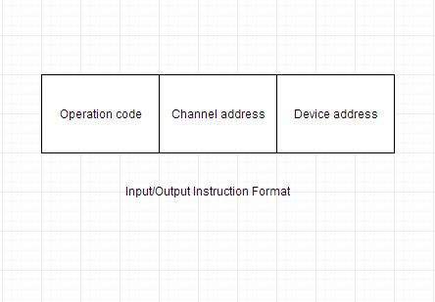
Instruction set architecture of a CPU

Registers:
A register is a group of flip-flops. Each flip flop is capable of storing one bit of information. Computer registers are high-speed memory storing units. It is an element of the computer processor. It can carry any type of information including a bit sequence or single data.
A register is a temporary storage area built into a CPU.Registers vary in both number and size, depending on the CPU architecture. Some Processors have 8 registers while others have 16, 32 or more. For many years, registers were 32-bit, but now many are 64 bit in size.
Register is a very fast computer memory, used to store data/instruction in execution. Computer Registers are designated by Capital letters (sometimes followed by numerals) to denote the function of the register.i.e. R1, R2……, Rn. The most common way to representation of registers by a rectangular box with the name of the register inside.
Types of Registers: There are two different types of Registers

1. General purpose Registers: These are numbered as R0, R1, and R2….Rn-1, and used to store temporary data during any ongoing operation. Its content can be accessed by assembly programming. Modern CPU architectures tends to use more GPR so that register-to-register addressing can be used more, which is comparatively faster than other addressing modes.

2. Special purpose Registers: Data Register, Address Register, Program Counter, Accumulator, Memory Address Register, Memory Data Register, Temporary Register, Instruction Register, Memory Buffer Register, Input Register, Output Register.

Following is the list of some of the most common registers used in a basic computer:
Register | Symbol | Number of bits | Function
Data register | DR | 16 | Holds memory operand
Address register | AR | 12 | Holds address for the memory
Accumulator | AC | 16 | Processor register
Instruction register | IR | 16 | Holds instruction code
Program counter | PC | 12 | Holds address of the instruction
Temporary register | TR | 16 | Holds temporary data
Input register | INPR | 8 | Carries input character
Output register | OUTR | 8 | Carries output character
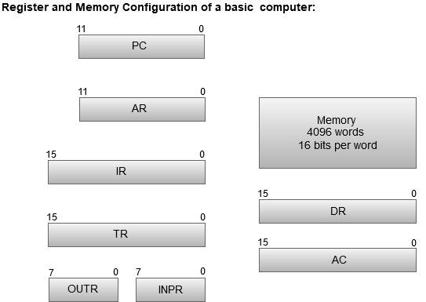

- The Memory unit has a capacity of 4096 words, and each word contains 16 bits.
- The Data Register (DR) contains 16 bits which hold the operand read from the memory location.
- The Memory Address Register (MAR) contains 12 bits which hold the address for the memory location.
- The Program Counter (PC) also contains 12 bits which hold the address of the next instruction to be read from memory after the current instruction is executed.
- The Accumulator (AC) register is a general purpose processing register.
- The instruction read from memory is placed in the Instruction register (IR).
- The Temporary Register (TR) is used for holding the temporary data during the processing.
- The Input Registers (IR) holds the input characters given by the user.
- The Output Registers (OR) holds the output after processing the input data.

Basic Operational Concepts of a Computer/Operation Performed by Registers:
- Fetch: The fetch operation is utilized for taking the directions by the client. The instructions that are stored away into the main memory for later processing are fetched by registers.
- Decode: This operation is utilized for deciphering the instructions implies the instructions are decoded the CPU will discover which operation is to be performed on the instructions.
- Execute: The CPU performs this operation. Also, results delivered by the CPU are then stored in the memory, and after that, they are shown on the client Screen.

Figure : Connection between the processor and the main memory

In addition to the ALU and the control circuitry, the processor contains a number of registers used for several different purposes.
The instruction register (IR) holds the instruction that is currently being executed. Its output is available to the control circuits, which generate the timing signals that control the various processing elements involved in executing the instruction.
Temporary register (TR) is used to hold temporary data while the processor is doing operations.
The program counter (PC) is another register. It contains the memory address of the next instruction to be fetched and executed. During the execution of an instruction, the contents of the PC are updated to correspond to the address of the next instruction to be executed.
In addition to the IR and PC, Figure (2) shows general-purpose registers R0 through Rn−1, often called as processor registers. They serve a variety of functions including holding operands that have been loaded from the memory for processing.
An Accumulator register (AC) is also called as a processors personal register because processor uses the AC register frequently for storing the data. Data register (DR) is to hold data (operands) and Address register (AR) is used to store address of the of memory location for read/write the data
Finally, there are some situations for storing the data comes from input devices and data goes to the output devices. Such kind of data stores in input register (INPR) and output register (OUPR).
- The processor-memory interface is a circuit which manages the transfer of data between the main memory and the processor. If a word is to be read from the memory, the interface sends the address of that word to the memory along with a Read control signal. The interface waits for the word to be retrieved, then transfers it to the appropriate processor register. If a word is to be written into memory, the interface transfers both the address and the word to the memory along with a Write control signal.

Instruction execution cycle

The basic function performed by a computer is execution of a program, which consists of a set of instructions stored in memory. The processor does the actual work by executing instructions specified in the program.
In its simple form, instruction processing consists of two steps: The processor reads (fetches) instructions from memory one at a time and executes each instruction. Program execution consists of repeating the process of instruction fetch and instruction execution.
The processing required for a single instruction is called an instruction cycle. Using the simplified two-step description given above, the instruction cycle is shown in Figure (3). The two steps are referred to as the fetch cycle and the execute cycle. Program execution halts only if the machine is turned off, some sort of unrecoverable error occurs, or a program instruction that halts the computer is encountered.
Figure (3): Basic Instruction Cycle

Instruction Fetch and Execute:
- At the beginning of each instruction cycle, the processor fetches an instruction from memory. In a typical processor, a register called the program counter (PC) holds the address of the instruction to be fetched next. Unless told otherwise, the processor always increments the PC after each instruction fetch so that it will fetch the next instruction in sequence (i.e., the instruction located at the next higher memory address).

- The fetched instruction is loaded into a register in the processor known as the instruction register (IR). The instruction contains bits (opcode) that specify the action the processor is to take. The processor interprets the instruction and performs the required action. In general, these actions fall into four categories:
- Processor-memory: Data may be transferred from processor to memory or from memory to processor.
- Processor-I/O: Data may be transferred from processor to an I/O device and vice-versa.
- Data processing: The processor may perform some arithmetic or logic operation on data.
- Control: An instruction may specify that the sequence of execution be altered. For example, the processor may fetch an instruction from location 149, which specifies that the next instruction be from location 182. The processor will remember this fact by setting the program counter to 182. Thus, on the next fetch cycle, the instruction will be fetched from location 182 rather than 150.

An instruction’s execution may involve a combination of these actions. Consider a simple example using a hypothetical machine that includes the characteristics listed in Figure (4). The processor contains a single data register, called an accumulator (AC). Both instructions and data are 16 bits long. Thus, it is convenient to organize memory using 16-bit words. The instruction format provides 4 bits for the opcode, so that there can be as many as 2⁴ = 16 different opcodes, and up to 2¹² = 4096 (4K) words of memory can be directly addressed.
(4a) Instruction format

(4b) Integer format

Program counter (PC) = Address of instruction
Instruction register (IR) = Instruction being executed
Accumulator (AC) = Temporary storage
(4c) Internal CPU registers

0001 = Load AC from memory
0010 = Store AC to memory
0101 = Add to AC from memory
(4d) Partial list of opcodes
Figure (4): Characteristics of a Hypothetical Machine

Figure (5): Example of Program Execution (contents of memory and registers in hexadecimal)
Figure (5) illustrates a partial program execution, showing the relevant portions of memory and processor registers. The program fragment shown adds the contents of the memory word at address 940 to the contents of the memory word at address 941 and stores the result at the address 941. Three instructions, which can
be described as three fetch and three execute cycles, are required:
1. The PC contains 300, the address of the first instruction. This instruction (the value 1940 in hexadecimal) is loaded into the instruction register IR and the PC is incremented to 301.
2. The first 4 bits (first hexadecimal digit) in the IR indicate that the AC is to be loaded. The remaining 12 bits (three hexadecimal digits) specify the address (940) from which data are to be loaded.
3. The next instruction (5941) is fetched from location 301, and the PC is incremented to 302.
4. The old contents of the AC and the contents of location 941 are added, and the result is stored in the AC (3+2=5).
5. The next instruction (2941) is fetched from location 302, and the PC is incremented to 303.
6. The contents of the AC are stored in location 941.
In this example, three instruction cycles, each consisting of a fetch cycle and an execute cycle, are needed to add the contents of location 940 to the contents of 941. With a more complex set of instructions, fewer cycles would be needed. Some older processors, for example, included instructions that contain more than one memory address. Thus, the execution cycle for a particular instruction on such processors could involve more than one reference to memory. Also, instead of memory references, an instruction may specify an I/O operation.
For example, the PDP-11 processor, an instruction expressed symbolically as ADD A,B that stores the sum of the contents of memory locations B and A into memory location A. A single instruction cycle with the following steps occurs:
- Fetch the ADD instruction.
- Read the contents of memory location A into the processor.
- Read the contents of memory location B into the processor.
- Add the two values.
- Write the result from the processor to memory location A.
Thus, the execution cycle for a particular instruction may involve more than one reference to memory. Also, instead of memory references, an instruction may specify an I/O operation. With these additional considerations in mind, Figure (6) provides a more detailed look at the basic instruction cycle of Figure (3). The figure is in the form of a state diagram. The states can be described as follows:
Figure (6): Instruction Cycle State Diagram
■ Instruction address calculation (iac): Determine the address of the next instruction to be executed. Usually, this involves adding a fixed number to the address of the previous instruction. For example, if each instruction is 16 bits long and memory is organized into 16-bit words, then add 1 to the previous address.
■ Instruction fetch (if): Read instruction from its memory location into the processor.
■ Instruction operation decoding (iod): Analyze instruction to determine type of operation to be performed and operand(s) to be used.
■ Operand address calculation (oac): If the operation involves reference to an operand in memory or available via I/O, then determine the address of the operand.
■ Operand fetch (of): Fetch the operand from memory or read it in from I/O.
■ Data operation (do): Perform the operation indicated in the instruction.
■ Operand store (os): Write the result into memory or out to I/O.
- The diagram allows for multiple operands and multiple results, because some instructions on some machines require this. For example, the PDP-11 instruction ADD A,B results in the following sequence of states: iac, if, iod, oac, of, oac, of, do, oac, os.

Interrupts and the instruction cycle:
- Virtually all computers provide a mechanism by which other modules (I/O, memory) may interrupt the normal processing of the processor.
- When the external device becomes ready to be serviced—that is, when it is ready to accept data from the processor—the I/O module for that external device sends an interrupt request signal to the processor. The processor responds by suspending operation of the current program, branching off to a program to service that particular I/O device, known as an interrupt handler, and resuming the original execution after the device is serviced.
- From the point of view of the user program, an interrupt is just that: an interruption of the normal sequence of execution. When the interrupt processing is completed, execution resumes (Figure (7)).
- Thus, the user program does not have to contain any special code to accommodate interrupts; the processor and the operating system are responsible for suspending the user program and then resuming it at the same point.
To accommodate interrupts, an interrupt cycle is added to the instruction cycle, as shown in Figure (8). In the interrupt cycle, the processor checks to see if any interrupts have occurred, indicated by the presence of an interrupt signal. If no interrupts are pending, the processor proceeds to the fetch cycle and fetches the next instruction of the current program. If an interrupt is pending, the processor does the following:
■ It suspends execution of the current program being executed and saves its context. This means saving the address of the next instruction to be executed (current contents of the program counter) and any other data relevant to the processor’s current activity.
■ It sets the program counter to the starting address of an interrupt handler routine. The processor now proceeds to the fetch cycle and fetches the first instruction in the interrupt handler program, which will service the interrupt. The interrupt handler program is generally part of the operating system. Typically, this program determines the nature of the interrupt and performs whatever actions are needed.
Figure (7): Transfer of Control via Interrupts
Figure (8): Instruction Cycle with Interrupts

Register Transfer language (RTL):
- A digital system is an interconnection of digital hardware modules.
- These modules are constructed from such digital components as registers, decoders, arithmetic elements, and control logic. The various modules are interconnected with common data and control paths to form a digital computer system.
A microoperation is an elementary operation performed on the information stored in one or more registers.
- It is possible to specify the sequence of microoperations in a computer by explaining every operation in words, but this procedure usually involves a lengthy descriptive explanation.
- It is more convenient to adopt a suitable symbology (using symbols) to describe the sequence of transfers between registers and the various arithmetic and logic microoperations associated with the transfers.
  - The symbolic notation used to describe the microoperation transfers among registers is called a

“Register Transfer Language (RTL)”.
  - The term "register transfer" implies the availability of hardware logic circuits that can perform a stated microoperation and transfer the result of the operation to the same or another register. The word "language" is borrowed from programmers, who apply this term to programming languages.
  - A register transfer language is a system for expressing in symbolic form the microoperation sequences among the registers of a digital module. It is a convenient tool for describing the internal organization of digital computers in concise and precise manner. It can also be used to facilitate the design process of digital systems.

Register Transfer:
→ A register is a quickly accessible small memory area by the CPU. It holds the data or an instruction or any other information temporarily.
Computer registers are designated by capital letters (sometimes followed by numerals) to denote the function of the register. For example, the register that holds an address for the memory unit is usually called a memory address register and is designated by the name MAR.
A register is represented by a rectangular box with the name of the register inside, as in Figure (a) shown in the below. The individual bits of register can be distinguished as in Figure (b). The numbering of bits in a 16-bit register can be marked on top of the box as shown in Figure (c). A 16-bit register is partitioned into two parts into two parts as in Figure (d). Bits 0 through 7 are assigned the symbol L (for low byte) and bits 8 through 15 are assigned the symbol H (for high byte). The name of the 16- bit register is PC. The symbol PC (0-7) or PC (L) refers to the low-order byte and PC (8-15) or PC to the high-order byte.
Computer registers can be represented in various ways, some of those are shown here:
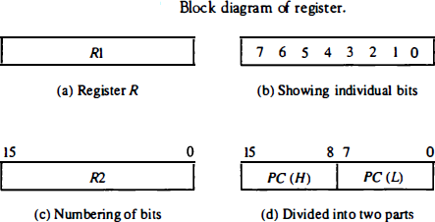

Information transfer from one register to another is designated in symbolic form by means of a replacement operator.
R2 ← R1
This statement denotes a transfer of the content of register R1 into register R2. It designates a replacement of the content of R2 by the content of R l . By definition, the content of the source register R1 does not change after the transfer.
- Normally, the transfer will occur only under a predetermined control condition. This can be shown by means of an if-then statement.
If (P = 1) then (R2 ← R1)
Where P is a control signal generated in the control section.
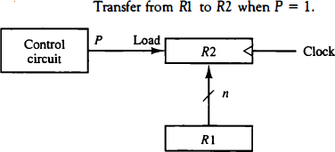
Every statement written in a register transfer notation implies a hardware construction for implementing the transfer. The below figure shows the block diagram that depicts the transfer from R1 to R2.
As shown in the timing diagram, P is activated in the control section by the rising edge of a clock pulse at time t. The next positive transition of the clock at time t + 1 finds the load input active and the data inputs of R2 are then loaded into the register in parallel. P may go back to 0 at time t + 1; otherwise, the transfer will occur with every clock pulse transition while P remains active.

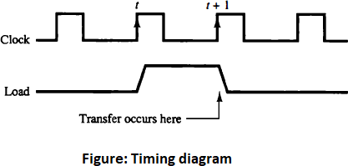
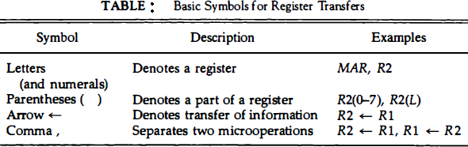
The basic symbols of the register transfer notation are listed in the below shown table.
- Registers are denoted by capital letters, and numerals may follow the letters.
- Parentheses are used to denote a part of a register by specifying the range of bits or by giving a symbol name to a portion of a register.
- The arrow denotes a transfer of information and the direction of transfer.
- A comma is used to separate two or more operations that are executed at the same time.

Memory Transfer:
The transfer of information from a memory word to the outside environment is called a read operation. The transfer of new information to be stored into the memory is called a write operation. A memory word will be symbolized by the letter M. The particular memory word among the many available is selected by the memory address during the transfer. It is necessary to specify the address of M when writing memory transfer operations. This will be done by enclosing the address in square brackets following the letter M.
Consider a memory unit that receives the address from a register, called the address register, symbolized by AR. The data are transferred to another register, called the data register, symbolized by DR. The read operation can be stated as follows:
Read: DR M [AR]
- This causes a transfer of information into DR from the memory word M selected by the address in AR. The write operation can be stated as follows:
Write: M [AR] R1
- This causes a transfer of information from R1 into the memory word M selected by the address in AR.

Types of Microoperations:
A microoperation is an elementary operation performed with the data stored in registers. The microoperations most often encountered in digital computers are classified into four categories:
  - Register transfer microoperations
  - Arithmetic microoperations
  - Logic microoperations
  - Shift microoperations
The basic arithmetic microoperations are addition, subtraction, increment, decrement, and shift. Arithmetic shifts are explained later in conjunction with the shift microoperations. The arithmetic microoperation defined by the statement
R3 R1+R2
It specifies an add microoperation. It states that the contents of register R1 are added to the contents of register R2 and the sum transferred to register R3.
Subtraction is most often implemented through complementation and addition. Instead of using the minus operator, we can specify the subtraction by the following statement:
is the 1’s complement of R2, Adding 1 to the 1’s Complement produces the 2’s Complement form. Adding the R1 to the 2’s complement of R2 is equivalent to R1-R2.
All the arithmetic microoperations are shown in the below Table (2).

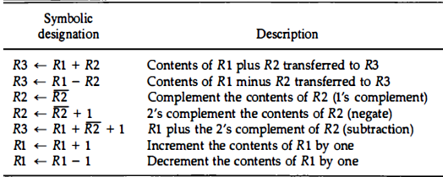
Table(2): Arithmetic Microoperations
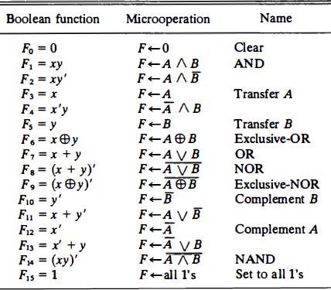
Logic microoperations specify binary operations for strings of bits stored in registers. The list of logic microoperations are shown in the below Table (3).

Table (3): Logic Microoperations

Shift Microoperations:
Shift rnicrooperations are used for serial transfer of data. The contents of a register can be shifted to the left or the right. At the same time that the bits are shifted, the first flip-flop receives its binary information from the serial input.
- During a shift-left operation the serial input transfers a bit into the rightmost position.
- During a shift-right operation the serial input transfers a bit into the leftmost position.
- The information transferred through the serial input determines the type of shift.
- There are three types of shifts:

Logical shift
  - Circular shift

Arithmetic shift
- Logical shift:
A logical shift is one that transfers 0 through the serial input. We will adopt the symbols shl and shr for logical shift-left and shift-right rnicrooperations. For example:
R1 shl R1 R2 shr R2
  - First statement specifies a 1-bit shift to the left of the content of register R1.
  - Second statement specifies 1-bit shift to the right of the content of register R2.
  - The register symbol must be the same on both sides of the arrow.
  - The bit transferred to the end position through the serial input is assumed to be 0 during a logical shift.

Circular shift:
The circular shift (also known as a rotate operation) circulates the bits of the register around the two ends without loss of information. This is accomplished by connecting the serial output of the shift register to its serial input. We will use the symbols cil and cir for the circular shift left and right, respectively.
The symbolic notation for the shift rnicrooperations is shown in the below table.
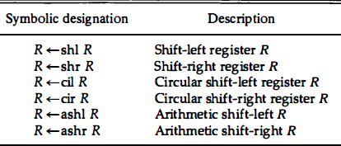

Arithmetic shift:
An arithmetic shift is a rnicrooperation that shifts a signed binary number to the left or right.
- An arithmetic shift-left multiplies a signed binary number by 2 and an arithmetic shift-right divides the number by 2.
- Arithmetic shifts must leave the sign bit unchanged because the sign of the number remains the same when it is multiplied or divided by 2.
- The arithmetic shift-right leaves the sign bit unchanged and shifts the number (including the sign bit) to the right.
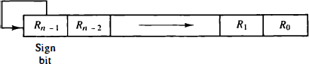
- The arithmetic shift-left inserts a 0 into R0 and shifts all other bits to the left. The initial bit of Rn-1 is lost and replaced by the bit from Rn-2. A sign reversal occurs if the bit in Rn-1 changes in value after the shift. This happens if the multiplication by 2 causes an overflow.
Figure (9): Arithmetic shift right.

Instruction formats:
A computer will usually have a variety of instruction code formats. It is the function of the control unit within the CPU to interpret each instruction code and provide the necessary control functions needed to process the instruction.
The bits of the instruction are divided into groups called fields. The most common fields found in instruction formats are:
  - An operation code field that specifies the operation to be performed.
  - An address field that designates the address of an operand or a processor register.
  - A mode field that specifies the way the operand or the effective address is determined.
Other special fields are sometimes employed under certain circumstances, as for example a field that gives the number of shifts in a shift-type instruction.

Instruction format with mode field

The basic computer has three types of instruction code formats based on opcode bits,
- Memory-reference instruction.
- Register-reference instruction.
- An input-output instruction.
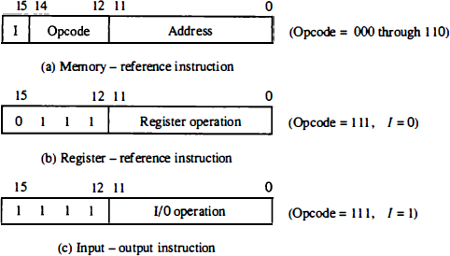
Each format has 16 bits. The operation code (opcode) part of the instruction contains three bits and the meaning of the remaining 13 bits depends on the operation code encountered.

Figure (10): Basic computer instruction formats
The type of instruction is recognized by the computer control from the four bits in positions 12 through 15 of the instruction.
- If the three opcode bits in positions 12 to 14 are not equal to 111, the instruction is a memory-reference type and the bit in position 15 is taken as the addressing mode I. A memory-reference instruction uses 12 bits to specify an address and one bit to specify the addressing mode I. I = 0 for direct address and I = 1 for indirect address.
- If the 3-bit opcode = 111, control then inspects the bit in position 15. If this bit = 0, the instruction is a register-reference type. These instructions use 16 bits to specify an operation.
- If the bit I = 1, the instruction is an input-output type. These instructions also use all 16 bits to specify an operation.
The instructions for the computer are listed in Table (4, 5, 6).
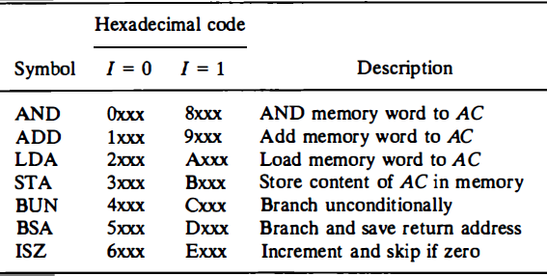
Table (4): Memory-reference instructions
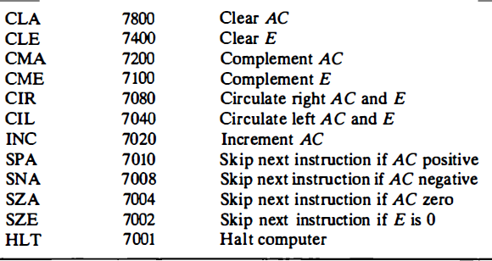
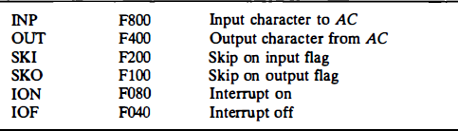
Table (5): Register-reference instructions
Table (6): Input-output instructions
The equivalent hexadecimal number of the binary code used for the instruction. By using the hexadecimal equivalent we reduced the 16 bits of an instruction code to four digits with each hexadecimal digit being equivalent to four bits.

- memory-reference instruction has an address part of 12 bits. The address part is denoted by three x's and stand for the three hexadecimal digits corresponding to the 12-bit address. The last bit of the instruction is designated by the symbol I.
  - When I = 0, the last four bits of an instruction have a hexadecimal digit equivalent from 0 (000) to 6 (110) since the last bit is 0.
  - When I = I, the hexadecimal digit equivalent of the last four bits of the instruction ranges from 8 (1000) to E (1110) since the last bit is I.
- Register-reference instructions use 16 bits to specify an operation. The leftmost four bits are always 0111, which is equivalent to hexadecimal 7. The other three hexadecimal digits give the binary equivalent of the remaining 12 bits.
- The input-output instructions also use all 16 bits to specify an operation. The last four bits are always 1111, equivalent to hexadecimal F.

In this section we are concerned with the address field of an instruction format and consider the effect of including multiple address fields in an instruction.
Operations specified by computer instructions are executed on some data stored in memory or processor registers. Operands residing in memory are specified by their memory address. Operands residing in processor registers are specified with a register address. A register address is a binary number of k bits that defines one of 2^{k}registers in the CPU.
Computers may have instructions of several different lengths containing varying number of addresses. The number of address fields in the instruction format of a computer depends on the internal organization of its registers. Most computers fall into one of three types of CPU organizations:
- Single accumulator organization.
- General register organization.
- Stack organization.

An accumulator-type organization:
All operations are performed with an implied accumulator register. The instruction format in this type of computer uses one address field. For example, the instruction that specifies an arithmetic addition is defined by an assembly language instruction as:

ADD X
where X is the address of the operand. The ADD instruction in this case results in the operation AC ← AC + M[X]. AC is the accumulator register and M [X] symbolizes the memory word located at address X.

A general register type of organization:
The instruction format in this type of computer needs three register address fields. Thus the instruction for an arithmetic addition may be written in an assembly language as

ADD R1 , R2 , R3
to denote the operation R 1 R2 + R 3 . The number o f address fields in the instruction can be reduced from three to two if the destination register is the same as one of the source registers. Thus the instruction

ADD R1 , R2
would denote the operation R1 R1 + R2. Only register addresses for R1 and R2 need be specified in this instruction.
General register-type computers employ two or three address fields in their instruction format. Each address field may specify a processor register or a memory word. An instruction symbolized by

ADD R1 , X
would specify the operation R1 R1 + M[X]. It has two address fields, one for register R1 and the other for the memory address X.

A stack organization:
Computers with stack organization would have PUSH and POP instructions which require an address field. Thus the instruction

PUSH X
will push the word at address X to the top of the stack. The stack pointer is updated automatically. Operation-type instructions do not need an address field in stack-organized computers. This is because the operation is performed on the two items that are on top of the stack. The instruction
ADD
in a stack computer consists of an operation code only with no address field. This operation has the effect of popping the two top numbers from the stack, adding the numbers, and pushing the sum into the stack. There is no need to specify operands with an address field since all operands are implied to be in the stack.
➔ To illustrate the influence of the number of addresses on computer programs, we will evaluate the arithmetic statement
X = (A + B) • (C + D)
using zero, one, two, or three address instructions. We will use the symbols ADD, SUB, MUL, and DIV for the four arithmetic operations; MOV for the transfer-type operation; and LOAD and STORE for transfers to and from memory and AC register. We will assume that the operands are in memory addresses A, B, C, and D, and the result must be stored in memory at address X.

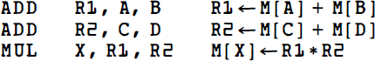
Three-Address Instructions:
Two-Address Instructions:
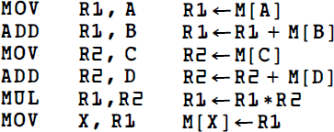

One-Address Instructions:
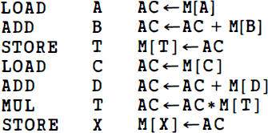
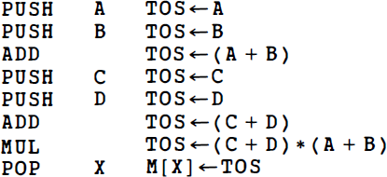
Zero-Address Instructions:
RISC Instructions:
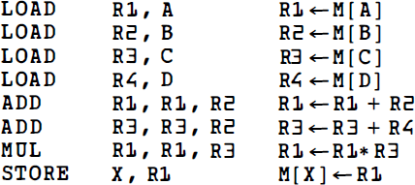

Computer instructions or an instruction set:
The set of instructions are defined for a particular processor is called as an instruction set. Computers provide an extensive set of instructions to give the user the flexibility to carry out various computational tasks. The instruction set of different computers differ from each other mostly in the way the operands are determined from the address and mode fields.
Most computer instructions can be classified into three categories:
  - Data transfer instructions
  - Data manipulation instructions
  - Program control instructions
Data transfer instructions cause transfer of data from one location to another without changing the binary information content.
Data manipulation instructions are those that perform arithmetic, logic, and shift operations. Program control instructions provide decision-making capabilities and change the path taken by the program when executed in the computer.
- Data transfer instructions
Data transfer instructions move data from one place in the computer to another without changing the data content. The most common transfers are between memory and processor registers, between processor registers and input or output, and between the processor registers themselves. Table (5) gives a list of eight data transfer instructions used in many computers.
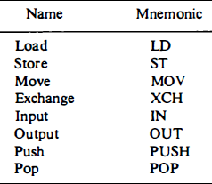
Table (7): Data Transfer Instructions
- The load instruction has been used mostly to designate a transfer from memory to a processor register, usually an accumulator.
- The store instruction designates a transfer from a processor register into memory.
- The move instruction has been used in computers with multiple CPU registers to designate a transfer from one register to another. It has also been used for data transfers between CPU registers and memory or between two memory words.
- The exchange instruction swaps information between two registers or a register and a memory word.
- The input and output instructions transfer data among processor registers and input or output terminals.
- The push and pop instructions transfer data between processor registers and a memory stack.
- Data Manipulation Instructions
Data manipulation instructions perform operations on data and provide the computational capabilities for the computer. The data manipulation instructions in a typical computer are usually divided into three basic types:
  - Arithmetic instructions
  - Logical and bit manipulation instructions
  - Shift instructions
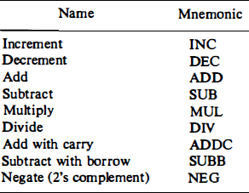
- Arithmetic instructions
Table (8): Arithmetic Instructions
- A special carry flip-flop is used to store the carry from an operation. The instruction "add with carry" performs the addition on two operands plus the value of the carry from the previous computation.
- Similarly, the "subtract with borrow" instruction subtracts two words and a borrow which may have resulted from a previous subtract operation.
- The negate instruction forms the 2' s complement of a number.

- Logical and Bit Manipulation Instructions
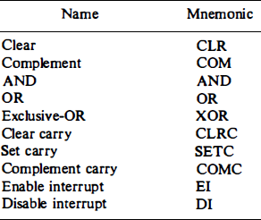
Logical instructions perform binary operations on strings of bits stored in registers. They are useful for manipulating individual bits or a group of bits that represent binary-coded information. The logical instructions consider each bit of the operand separately and treat it as a Boolean variable.
Table (9): Logic and Bit Manipulation Instructions
- Shift Instructions
Instructions to shift the content of an operand are quite useful and are often provided in several variations. Shifts are operations in which the bits of a word are moved to the left or right. The bit shifted in at the end of the word determines the type of shift used. Shift instructions may specify logical shifts, arithmetic shifts, or rotate-type operations. In either case the shift may be to the right or to the left.
The rotate through carry instruction treats a carry bit as an extension of the register whose word is being rotated. Thus a rotate-left through carry instruction transfers the carry bit into the rightmost bit position of the register, transfers the leftmost bit position into the carry and at the same time, and shifts the entire register to the left.
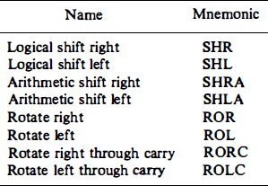
Table (10): Shift Instructions
A possible instruction code format of a shift instruction may include five fields as follows:

OP REG TYPE RL COUNT
OP - operation code field
REG - a register address that specifies the location of the operand
TYPE - a 2-bit field specifying the four different types of shifts
RL - a 1-bit field specifying a shift right or left
COUNT - a k-bit field specifying up to 2^{k} - 1 shifts

Program Control instructions:
After the execution of a data transfer or data manipulation instruction, control returns to the fetch cycle with the program counter containing the address of the instruction next in sequence.
On the other hand, a program control type of instruction, when executed, may change the address value in the program counter and cause the flow of control to be altered. In other words, program control instructions specify conditions for altering the content of the program counter, while data transfer and manipulation instructions specify conditions for data-processing operations.
The change in value of the program counter as a result of the execution of a program control instruction causes a break in the sequence of instruction execution. This is an important feature in digital computers, as it provides control over the flow of program execution and a capability for branching to different program segments.

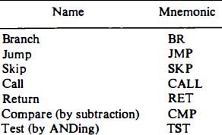
Table (11) : Program Control Instructions

RISC vs CISC:
  - An important aspect of computer architecture is the design of the instruction set for the processor.
  - Early computers had small and simple instruction sets, forced mainly by the need to minimize the hardware used to implement them .
  - As digital hardware became cheaper with the advent of integrated circuits, computer instructions tended to increase both in number and complexity. Many computers have instruction sets that include more than 100 and sometimes even more than 200 instructions. These computers also employ a variety of data types and a large number of addressing modes.
RISC and CISC are two different styles of instruction sets.
A computer with a large number of instructions is classified as a complex instruction set computer, abbreviated CISC.
In the early 1980s, a number of computer designers recommended that computers use fewer instructions with simple constructs so they can be executed much faster within the CPU without having to use memory as often. This type of computer is classified as a reduced instruction set computer or RISC.

CISC Characteristics
The major characteristics of CISC architecture are:
- More complex addressing modes
- More complex instructions, where an instruction may span multiple words
- Many instructions that implement complex tasks- typically from 100 to 250 instructions
- Some instructions that perform specialized tasks and are used infrequently
- Arithmetic and logic operations that can be performed on memory operands as well as operands in processor registers
- Transfers from one memory location to another by using a single Move instruction
- Programs that tend to be smaller in size, because fewer, but more complex instructions are needed to perform complex tasks.

RISC Characteristics
The concept of RISC architecture involves an attempt to reduce execution time by simplifying the instruction set of the computer The major characteristics of RISC architecture are:
- Simple addressing modes
- All instructions fitting in a single word
- Fixed-length, easily decoded instruction format
- Single-cycle instruction execution
- Fewer instructions in the instruction set, as a consequence of simple addressing modes
- Arithmetic and logic operations that can be performed only on operands in processor registers
- Load/store architecture that does not allow direct transfers from one memory location to another; such transfers must take place via a processor register
- Simple instructions that are conducive to fast execution by the processing unit using techniques such as pipelining.
- Programs that tend to be larger in size, because more, but simpler instructions are needed to perform complex tasks.

Addressing Modes:

The operation field of an instruction specifies the operation to be performed. This operation must be executed on some data stored in computer registers or memory words. The way the operands are chosen during program execution is dependent on the addressing mode of the instruction. The addressing mode specifies a rule for interpreting the address field of the instruction before the operand is actually referenced.
In simple terms, Addressing mode is the way in which the location of an operand can be specified in an instruction. It generates an effective address (the actual address of the operand).

Instruction format with mode field

Types of Addressing Modes:
- Implied Mode
- Immediate Mode
- Register Mode
- Register Indirect Mode:
- Autoincrement or Autodecrement Mode
- Direct Address Mode
- Indirect Address Mode
- Relative Address Mode
- Indexed Addressing Mode
- Base Register Addressing Mode

- There are two modes that need no address field at all. These are the implied and immediate modes.
- Implied Mode: In this mode the operands are specified implicitly in the definition of the instruction.
For example, the instruction “complement accumulator (CMA)” is an implied-mode instruction because the operand in the accumulator register is implied in the definition of the instruction. In fact, all register reference instructions that use an accumulator are implied-mode instructions. Zero-address instructions (like POP, ADD) in a stack-organized computer are implied-mode instructions since the operands are implied to be on top of the stack.
- Immediate Mode: In this mode the operand is specified in the instruction itself. In other words, an immediate-mode instruction has an operand field rather than an address field. The operand field contains the actual operand to be used in conjunction with the operation specified in the instruction.
EX: LDAC #34H
LDAC loads data #34H into accumulator. Therefore, AC=00110100.

- When the address field specifies a processor register, the instruction is said to be in the register mode.
- Register Mode: In this mode the operands are in registers that reside within the CPU. The particular register is selected from a register field in the instruction.
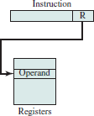
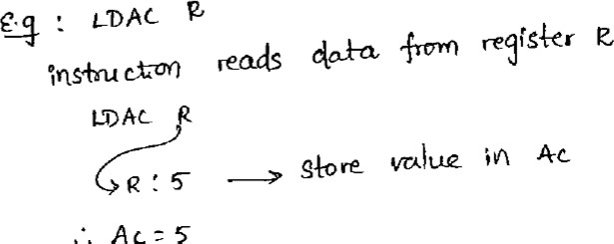
- Register Indirect Mode: In this mode the instruction specifies a register in the CPU whose contents give the address of the operand in the memory. In other words, the selected register contains the address of the operand rather than the operand itself.
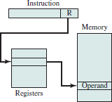
EX: LDAC (R1)
If R1 contains the address of an operand in the memory, for example: address of an operand is 2000 which contains a value 350. Result: 350 is stored in the AC.
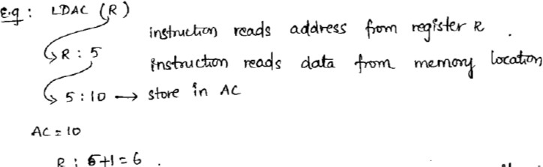
- Autoincrement Mode: This is similar to the register indirect mode except that the register is incremented after its value is used to access memory. The effective address of the operand is the contents of a register specified in the instruction. After accessing the operand, the contents of the register are automatically incremented to the next value.

- Autodecrement Mode
The effective address of the operand is the contents of a register specified in the instruction. Before accessing the operand, the contents of this register are automatically decremented and then the value is accessed.
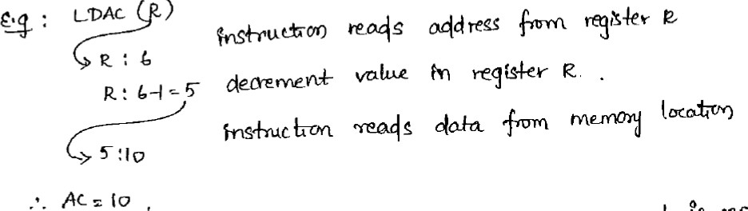

- Sometimes the value given in the address field is the address of the operand, but sometimes it is just an address from which the address of the operand is calculated.
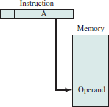
- Direct Address Mode: In this mode the effective address is equal to the address part of the instruction. The operand resides in memory and its address is given directly by the address field of the instruction.

Ex: LDAC 5000
This instruction reads the operand from the Memory location 5000. If the memory location 5000 contains a value 250, then it will be stored in AC.
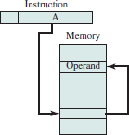
- Indirect Address Mode: In this mode the address field of the instruction gives the address where the effective address is stored in memory.

EX: ADD (A), R1
- If A is the address of EA. For example: address in A is 1000 which contains 3000, 3000 is the address of an operand (EA).
- This instruction reads an operand from the location address 3000 and adds its contents to R1.
- A few addressing modes require that the address field of the instruction be added to the content of a specific register in the CPU. The effective address in these modes is obtained from the following computation:

Effective Address = address part of instruction + content of CPU register
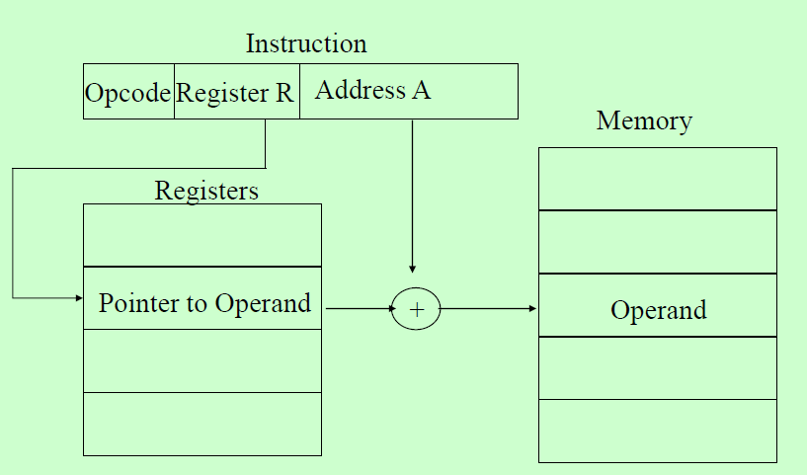
The CPU register used in the computation may be the program counter, an index register, or a base register. In either case we have a different addressing mode which is used for a different application.

- Relative Address Mode:
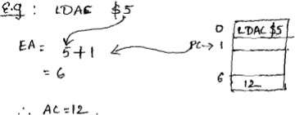
In this mode the content of the program counter is added to the address part of the instruction in order to obtain the effective address.

EX:
PC= address of next instruction , i.e., 1. The address given in the instruction is 5 Then EA= 5 + 1= 6 which contains a value 12. Finally AC contains 12.
- Indexed Addressing Mode:
In this mode the content of an index register is added to the address part of the instruction to obtain the effective address
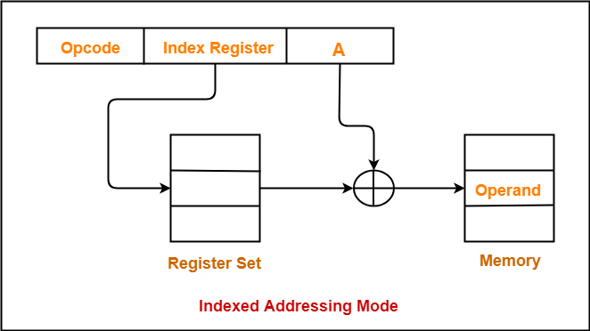

Ex: LDAC A(XR)
Assume XR=100, A=500
This instruction reads the operand from the effective address (600) i.e., EA= XR contents (index register) + 500
= 100 + 500=600
If memory location at 600 contains a value 55 (assume), This 55 will be stored in AC.
- Base Register Addressing Mode:
In this mode the content of a base register is added to the address part of the instruction to obtain the effective address.

Ex: LDAC A(R) Assume R=1000, A=50
This instruction reads the operand from the effective address (1050) i.e.,
EA= R contents (Base register) + 50

= 1000 + 50=1050
If memory location at 1050 contains a value 255 (assume), this 255 will be stored in AC.
Numerical Example:
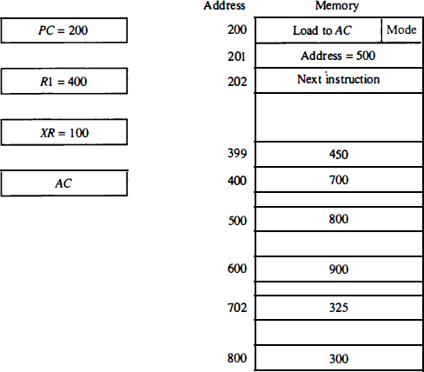
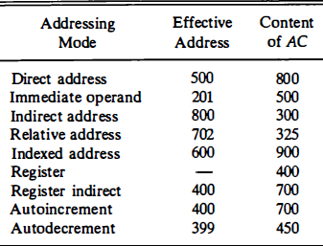
Table (12): Tabular list of some addressing modes of numerical example.

